**四川开放大学直属学院文件**

川开大直院发〔2022〕12 号

关于四川开放大学校本部面授教学调整为

在线教学的通知



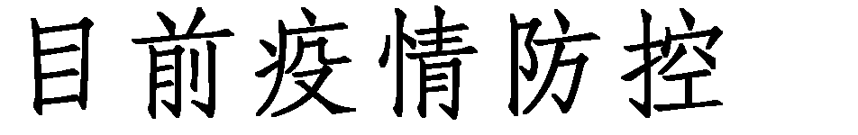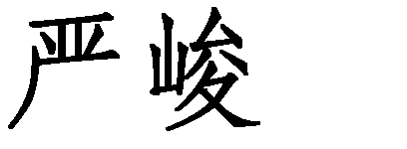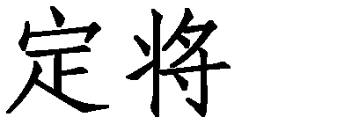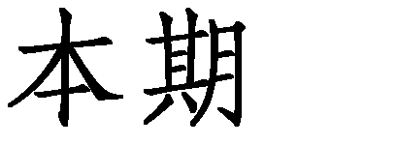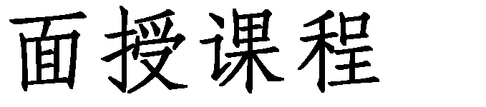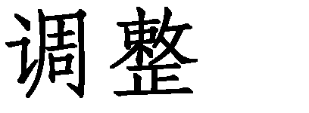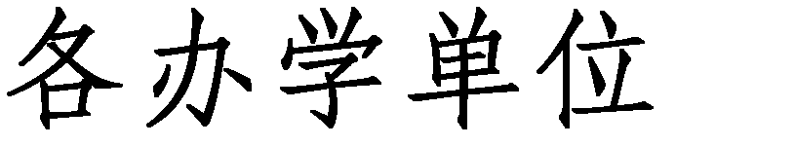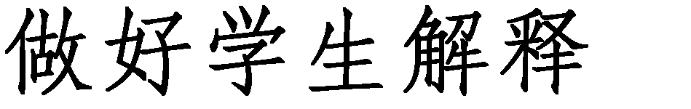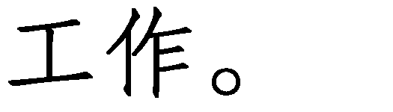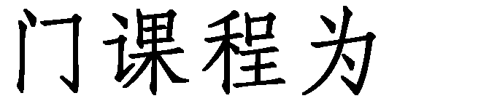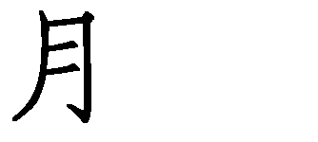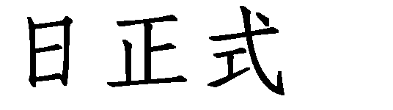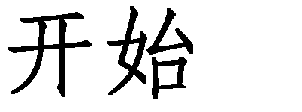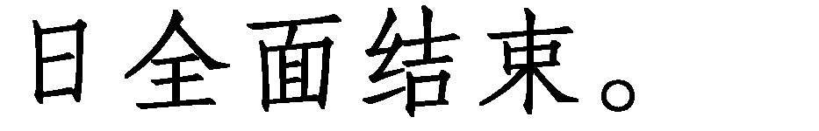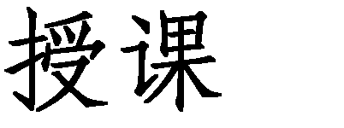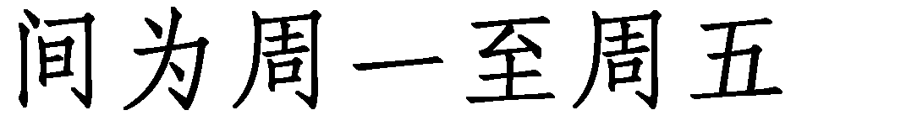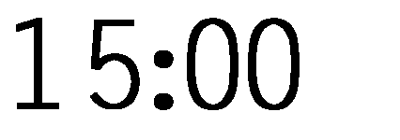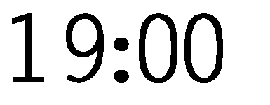



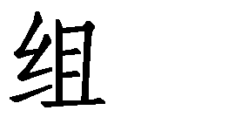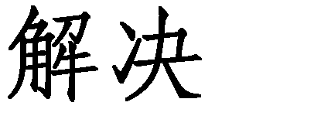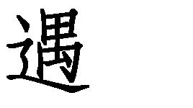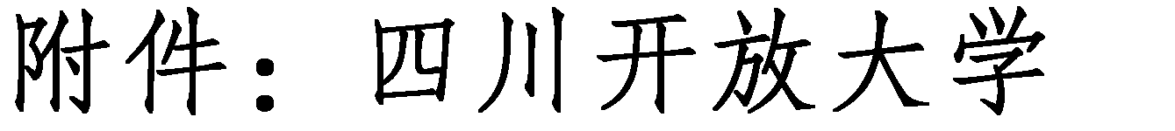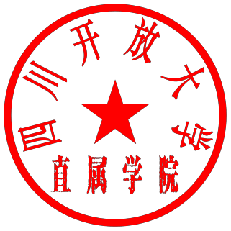





**四川开放大学校本部线上直播课堂课程总表**

|  |  |  |  |  |  |
| --- | --- | --- | --- | --- | --- |
|  |  |  |  |  |  |
|  |  |  |  |  |  |
|  |  |  |  |  |  |
|  |  |  |  |  |  |
|  |  |  |  |  |  |
|  |  |  |  |  |  |
|  |  |  |  |  |  |
|  |  |  |  |  |  |
|  |  |  |  |  |  |
|  |  |  |  |  |  |
|  |  |  |  |  |  |
|  |  |  |  |  |  |
|  |  |  |  |  |  |
|  |  |  |  |  |  |
|  |  |  |  |  |  |
|  |  |  |  |  |  |
|  |  |  |  |  |  |
|  |  |  |  |  |  |

|  |  |  |  |  |  |
| --- | --- | --- | --- | --- | --- |
|  |  |  |  |  |  |
|  |  |  |  |  |  |
|  |  |  |  |  |  |
|  |  |  |  |  |  |
|  |  |  |  |  |  |
|  |  |  |  |  |  |
|  |  |  |  |  |  |
|  |  |  |  |  |  |
|  |  |  |  |  |  |
|  |  |  |  |  |  |
|  |  |  |  |  |  |
|  |  |  |  |  |  |
|  |  |  |  |  |  |
|  |  |  |  |  |  |
|  |  |  |  |  |  |
|  |  |  |  |  |  |
|  |  |  |  |  |  |
|  |  |  |  |  |  |
|  |  |  |  |  |  |
|  |  |  |  |  |  |

|  |  |  |  |  |  |
| --- | --- | --- | --- | --- | --- |
|  |  |  |  |  |  |
|  |  |  |  |  |  |
|  |  |  |  |  |  |
|  |  |  |  |  |  |
|  |  |  |  |  |  |
|  |  |  |  |  |  |
|  |  |  |  |  |  |
|  |  |  |  |  |  |
|  |  |  |  |  |  |
|  |  |  |  |  |  |
|  |  |  |  |  |  |
|  |  |  |  |  |  |
|  |  |  |  |  |  |
|  |  |  |  |  |  |
|  |  |  |  |  |  |
|  |  |  |  |  |  |
|  |  |  |  |  |  |
|  |  |  |  |  |  |
|  |  |  |  |  |  |

|  |  |  |  |  |  |
| --- | --- | --- | --- | --- | --- |
|  |  |  |  |  |  |
|  |  |  |  |  |  |
|  |  |  |  |  |  |
|  |  |  |  |  |  |
|  |  |  |  |  |  |
|  |  |  |  |  |  |
|  |  |  |  |  |  |
|  |  |  |  |  |  |
|  |  |  |  |  |  |
|  |  |  |  |  |  |
|  |  |  |  |  |  |
|  |  |  |  |  |  |
|  |  |  |  |  |  |
|  |  |  |  |  |  |
|  |  |  |  |  |  |
|  |  |  |  |  |  |
|  |  |  |  |  |  |
|  |  |  |  |  |  |
|  |  |  |  |  |  |
|  |  |  |  |  |  |

|  |  |  |  |  |  |
| --- | --- | --- | --- | --- | --- |
|  |  |  |  |  |  |
|  |  |  |  |  |  |
|  |  |  |  |  |  |
|  |  |  |  |  |  |
|  |  |  |  |  |  |
|  |  |  |  |  |  |
|  |  |  |  |  |  |
|  |  |  |  |  |  |
|  |  |  |  |  |  |
|  |  |  |  |  |  |
|  |  |  |  |  |  |
|  |  |  |  |  |  |
|  |  |  |  |  |  |
|  |  |  |  |  |  |
|  |  |  |  |  |  |
|  |  |  |  |  |  |
|  |  |  |  |  |  |
|  |  |  |  |  |  |
|  |  |  |  |  |  |
|  |  |  |  |  |  |
|  |  |  |  |  |  |

|  |  |  |  |  |  |
| --- | --- | --- | --- | --- | --- |
|  |  |  |  |  |  |
|  |  |  |  |  |  |
|  |  |  |  |  |  |
|  |  |  |  |  |  |
|  |  |  |  |  |  |
|  |  |  |  |  |  |
|  |  |  |  |  |  |
|  |  |  |  |  |  |
|  |  |  |  |  |  |
|  |  |  |  |  |  |
|  |  |  |  |  |  |
|  |  |  |  |  |  |
|  |  |  |  |  |  |
|  |  |  |  |  |  |
|  |  |  |  |  |  |
|  |  |  |  |  |  |
|  |  |  |  |  |  |
|  |  |  |  |  |  |
|  |  |  |  |  |  |
|  |  |  |  |  |  |

|  |  |  |  |  |  |
| --- | --- | --- | --- | --- | --- |
|  |  |  |  |  |  |
|  |  |  |  |  |  |
|  |  |  |  |  |  |
|  |  |  |  |  |  |
|  |  |  |  |  |  |
|  |  |  |  |  |  |
|  |  |  |  |  |  |
|  |  |  |  |  |  |
|  |  |  |  |  |  |
|  |  |  |  |  |  |
|  |  |  |  |  |  |
|  |  |  |  |  |  |
|  |  |  |  |  |  |
|  |  |  |  |  |  |
|  |  |  |  |  |  |
|  |  |  |  |  |  |
|  |  |  |  |  |  |
|  |  |  |  |  |  |
|  |  |  |  |  |  |
|  |  |  |  |  |  |

|  |  |  |  |  |  |
| --- | --- | --- | --- | --- | --- |
|  |  |  |  |  |  |
|  |  |  |  |  |  |
|  |  |  |  |  |  |
|  |  |  |  |  |  |
|  |  |  |  |  |  |
|  |  |  |  |  |  |
|  |  |  |  |  |  |
|  |  |  |  |  |  |
|  |  |  |  |  |  |
|  |  |  |  |  |  |
|  |  |  |  |  |  |
|  |  |  |  |  |  |
|  |  |  |  |  |  |
|  |  |  |  |  |  |
|  |  |  |  |  |  |
|  |  |  |  |  |  |
|  |  |  |  |  |  |
|  |  |  |  |  |  |
|  |  |  |  |  |  |
|  |  |  |  |  |  |

|  |  |  |  |  |  |
| --- | --- | --- | --- | --- | --- |
|  |  |  |  |  |  |
|  |  |  |  |  |  |
|  |  |  |  |  |  |
|  |  |  |  |  |  |
|  |  |  |  |  |  |
|  |  |  |  |  |  |
|  |  |  |  |  |  |
|  |  |  |  |  |  |
|  |  |  |  |  |  |
|  |  |  |  |  |  |
|  |  |  |  |  |  |
|  |  |  |  |  |  |
|  |  |  |  |  |  |
|  |  |  |  |  |  |
|  |  |  |  |  |  |
|  |  |  |  |  |  |
|  |  |  |  |  |  |
|  |  |  |  |  |  |
|  |  |  |  |  |  |
|  |  |  |  |  |  |
|  |  |  |  |  |  |

|  |  |  |  |  |  |
| --- | --- | --- | --- | --- | --- |
|  |  |  |  |  |  |
|  |  |  |  |  |  |
|  |  |  |  |  |  |
|  |  |  |  |  |  |